**Content**

1. Docker community edition configuration 2

1. Storage driver 2

2. Docker run 2

3. Docker other commands 3

4. Logging drivers 3

1. Docker community edition configuration
   1. Storage driver

Provide a pluggable framework for managing the temporary, internal storage of a container’s writable layer. The best storage driver depends on the environemnt and on the needs.

overlay2: File-based storage, default for Ubuntu and CentOS 8+

devicemapper: Blcik storage, more efficient for doing lots of writes.

Docker info shows the current dewice mapper in use.

Docker daemon

sudo vi /usr/lib/systemd/system/docker.service

# docker daemon configuration The preferred way. By default does not exists

sudo vi /etc/docker/daemon.json

# restarting docker after editing the configuration

sudo systemctl restart docker

sudo systemctl status docker

* 1. Docker run

docker run [OPTIONS] IMAGE[:TAG] [COMMAND] [ARG...]

-d , --detach

Run the container in background and print the container ID. The run command will exit.

-i , --interactive

Keep STIN open even if not attached

-a , --attach

Attach to STDIN, STDOUT or STDERR

--rm

Automatically remove container when it exits (when it stops running).

-t , --tty

Allocate a pseudo-TTY

-p , --publish

Publish a container port to the host

--name

A container is assigned to a random name by default, but u can assign new

--restart

When the container should be automatically restarted

[“no”, “on-failure”, “always”, “unless-stopped”]

* 1. Docker other commands

# list running containers

docker ps

# list all containers

docker ps -a

docker container stop nginx

docker container start nginx

# delete a container (it must be stopped first)

docker container rm nginx

* 1. Logging drivers

Logging drivers are pluggable framework for accessing log data from services and containers in Docker.

# log driver can be set in the docker deamon config

sudo vi /etc/docker/daemon.json

# check the current loggin driver

docker info | grep Logging

# to find where the json-file logging driver is logging

docker inspect --format='{{.LogPath}}' NAME|ID

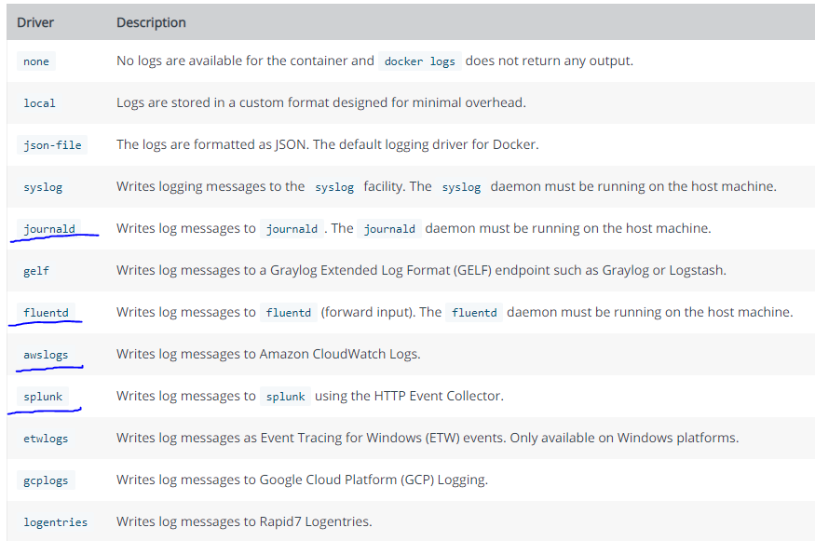

**Journald** is a system service for collecting and storing log data, introduced with systemd. It tries to make it easier for system administrators to find interesting and relevant information among an ever-increasing amount of log messages.

**Fluentd** is a cloud native logging solution to unify data collection and consumption.

**json-file** -by default, Docker captures the standard output (and standard error) of all your containers, and writes them in files using the JSON format. The JSON format annotates each line with its origin (stdout or stderr) and its timestamp. Each log file contains information about only one container.